

HCVS

Web Application Style Guide
Template 1.0

eCommerce

Version 0.3

Craig Turberfield, Business Analyst

16 September 2009

13 Bruton Street
London
W1J 6QA
Tel: +44 (0)20 7333 0033
Fax: +44 (0)20 7333 0032

Email: craig.turberfield@harveynash.com

RECORD OF CHANGE

History of Amendments
Date | Version | Modified Section | Summary of Change | Author
2 Sep 2009 | 0.1 | - | Initial input | Daniel Hobson
9 Sep 2009 | 0.2 | - | Draft completed, ready for review | Craig Turberfield
16 Sep 2009 | 0.3 | 2.6, 2.7, 2.8  2.6  2.3, 2.9  2.10  2.19 | Corrected text colours of buttons, menus and hyperlinks  HCVS to provide example of button style  Amended rules on page width and horizontal scrolling  Added row rollover colour to grids  Clarification on image file sizes | Craig Turberfield
Distributed for Review
This document has been distributed for the following to review:
Name | Title & Company | Issue Date | Revision
Patrick Power | HCVS Project Manager | 9 Sep 2009 | 0.2
Ted Griffiths | HCVS Business Analyst | 9 Sep 2009 | 0.2
Daniel Hobson | HC CRM and eBusiness Manager | 16 Sep 2009 | 0.3
Hester Grainger | HC Corporate Communications Manager | 9 Sep 2009 | 0.2
Rebecca Harty | HCVS Marketing Manager | 9 Sep 2009 | 0.2
Truong Do | HN Technical Architect | 9 Sep 2009 | 0.2
Hanh Nguyen | HN Business Analyst | 16 Sep 2009 | 0.3
Bob Ahern | HN Engagement Manager | 9 Sep 2009 | 0.2
Phu Nguyen | HN Offshore Project Manager | 9 Sep 2009 | 0.2
Abid Warsi | Webcredible | 9 Sep 2009 | 0.2
Alex Baxevanis | Webcredible User Experience Consultant | 9 Sep 2009 | 0.2
Approvals
This document requires the following approvals:
Name | Title | Signature | Approval Date
John Atkinson | HC Head of Marketing
Associated Documents
This document is associated with the following other documents:
Title | Source | Issue Date | Version
Visual identity guidelines | Hitachi Capital Marketing | June 2008
Software Requirements Specification | HN SharePoint Server |  | 1.0
CONFIDENTIALITY
This document is distributed on a restricted basis, is commercial in confidence to the recipient, and may not be used for any purpose other than that associated with a Harvey Nash project. The contents of this document may not be disclosed to any third parties without the expressed advance written authorisation of Harvey Nash.
TABLE OF CONTENTS

1 OVERVIEW 5
1.1 Purpose 5
1.2 Audience 5
1.3 Use of document 5
1.4 Source 5
2 STYLE GUIDE 5
2.1 Browser support 5
2.2 Branding 6
2.3 Layout 6
2.4 Text 7
2.5 Colours 8
2.6 Buttons 8
2.7 Menus 8
2.8 Hyperlinks 9
2.9 Scrolling 9
2.10 Grids 9
2.11 Tabs 9
2.12 Input 10
2.13 Tree views 10
2.14 Tool tips 10
2.15 Windows 10
2.16 Saving data 11
2.17 Validation 11
2.18 Visual effects 11
2.19 Images 11
2.20 International 11
2.21 Formatting 11
2.22 Compliance with standards 12

OVERVIEW

Purpose
The purpose of this document is to provide a comprehensive set of style guidelines for presenting the user interface of a web application. This document will form part of the software requirements. The intention is to provide sufficient information to the development team such that they can develop the user interface of a web application to suit the customer.

This document aims to minimise the number of clarification questions that are raised by the development team during the construction of the software. The greater the clarity that can be provided up front in relation to the user interface, the more efficient the development and testing processes will be.

Audience
The key stakeholders for this document will be:
- customer marketing manager
- customer brand manager
- graphic designer
- development team
- testing team
- requirements sign-offs
- business analyst

Use of document
Some user interface elements listed below may not be appropriate in all cases. This depends on the type and style of website being developed. This document should be treated as a checklist of user interface elements to consider. Sections which are not relevant to the project should be deleted.

Source
This document has been put together from the perspective of the software delivery team. In doing so, the document should contain all the UI information that the delivery team needs to know.

However, this information may originate from various customer sources. Some information may be part of a company’s existing brand guidelines, whereas other information may be specific to the project or website. It does not matter where this information is sourced, as long as there are no conflicts or ambiguity in the final agreed guidelines.

STYLE GUIDE

Browser support
Ref | Requirement
 | The browsers, versions and operating systems supported are detailed in the Software Requirements Specification.
 | The use of JavaScript is permitted.
 | The use of AJAX is permitted.
 | The use of Flash is generally not permitted.
 | The browser Back button should always navigate to the previous screen in the page history.

Branding
Ref | Requirement
 | The logo should always be placed on a white background.
There are two logo options for use in a web context:

Version one, right hand side: When used in the right hand side of a banner or header, the standard logo should be used (height = 63% of the width, see gif 358 x 568) – and should be sized 158 x 100 pixels.

Version two, left hand sized: When used on the left hand side of a banner or header, the squarer, web logo as seen on http://www.hitachicapitalvehiclesolutions.co.uk/ should be used 159 x 140 pixels.
 | Please refer to the Visual identity guidelines for more detailed notes on logo usage and context.

Layout
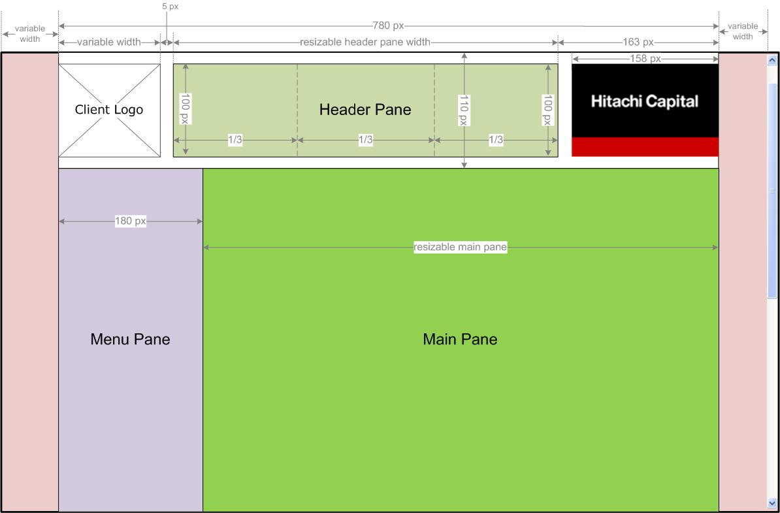
Figure 1 - eCommerce layout

Ref | Requirement
The main eCommerce screens are made up of the following areas:

- Client Logo (where applicable) – top left
- Header Pane – top centre, split into 3 equal sub panes in order to display multiple pieces of information, e.g. HCVS phone number and user login name.
- Hitachi Capital logo – top right
- Menu Pane – left hand side, below Header Pane
- Main Pane – to right of Menu Pane

See Figure 1 - eCommerce layout for more precise layout measurements.
 | The Hitachi Capital logo should be displayed in the top right corner.
 | Where used, the client logo should be displayed in the top left corner.
 | The logos and Header Pane should be vertically aligned.
 | If used, the Client Logo should be left aligned to the Menu Pane. If there is no Client Logo, the Menu Pane should be left aligned to the Header Pane.
 | The maximum width of page content should be 960px.
 | The page content should be a fixed width (960px), so that the content layout or wrapping does not change when the browser width is altered.
When the width of the browser window is expanded, the maximum width of the visible web page content should be 960px, centred horizontally in the browser window.

If the browser window is expanded to show more than 960px of content, there should be white space to the left and right of the eCommerce page content.
 | Grids
 | There are no minimum or maximum heights.
 | There should be no frames.
 | There should be no drag bars.
 | Text should be left aligned within each pane.

Text
Ref | Requirement
 | Hitachi Capital and Hitachi Capital Vehicle Solutions should always be written out in full for external purposes, not as HC, HCUK or HCVS.
 | Heading font: Arial, Helvetica, sans-serif; 15px, #333333 (dark grey), Bold
 | Paragraph font: Arial, Helvetica, sans-serif; 12px, #494949 (medium grey), Normal
 | Other text decorations such as bold, italics and underline should not be used, aside from the above rules.
 | The above font sizes are for ‘Medium’ browser text size. Fonts should resize according to the browser ‘Text Size’ settings.

Colours
Ref | Requirement
 | Heading font colour: #333333 (dark grey)
 | Paragraph font colour: #494949 (medium grey)
 | Background colour: #FFFFFF (white)
 | Border colour: #CCCCCC (light grey)
Corporate colours can be used, where appropriate:
#FFFFFF (white)
#000000 (black)
#E00034 (red)
 | Any of the secondary colours may be used, where appropriate, detailed in the Visual identity guidelines.

Buttons
Ref | Requirement
 | Buttons can be used on a web page in order to perform specific functions.
 | Navigation should be provided primarily through the left hand menu pane. Additional navigation from one screen to another can be provided by buttons.
 | Buttons should be positioned wherever required. There are no specified alignment rules.
 | Buttons should have a height of 25px.
 | The width of a button should expand in relation to the text label. Buttons should fit the text label with 5px margin, left and right.
 | The style of the buttons is to be provided separately by HCVS.
 | Each button should contain both an icon and text label which changes on rollover.
Standard: Arial, Helvetica, sans-serif; #333333 (dark grey); Text-decoration: None
Rollover: Arial, Helvetica, sans-serif; Text-decoration: Underline
 | There is no requirement to show a ‘depressed’ button state.

Menus
Ref | Requirement
 | The menus will be displayed in the left hand Menu Pane only.
 | The menus will be implemented very similar to http://www.hitachicapitalvehiclesolutions.co.uk
 | Menus exist on two levels: top-level and sub menus.
 | When clicking on a top-level menu, it expands to show its sub menus.
Top-level menus and sub menus use the following fonts:
- Standard: Arial, Helvetica, sans-serif; #333333 (dark grey); Text-decoration: None
- Rollover: Arial, Helvetica, sans-serif; Text-decoration: Underline
 | Top-level font size: 12px
 | Sub menu font size: 10px
 | Arrow icons are displayed against each top-level menu to indicate whether it is expanded or collapsed.
 | Each group of menus has a light grey border (#CCCCCC).
 | A tooltip is displayed when hovering over each menu.

Hyperlinks
Ref | Requirement
 | Standard font style: Arial, Helvetica, Sans Serif, #494949 (medium grey), text-decoration: none
 | Rollover font style: Arial, Helvetica, Sans Serif, #494949 (medium grey), text-decoration: underline
 | All links should open in the existing browser window.
 | Visited links are not treated differently.
 | A tooltip is display when hovering over each link.

Scrolling
Ref | Requirement
 | Vertical scrolling is allowed.
 | Horizontal scrolling should only be used if the user reduces the browser content window to less than 960px wide.
 | The default style of browser scroll bar should be used.

Grids
Ref | Requirement
 | Background colour: #FFFFFF (white)
 | Border colour (internal and external): #CCCCCC (light grey)
 | Border width (internal and external): 1px
 | Cell padding: 3px
 | Heading text: Arial, Helvetica, Sans Serif, text-decoration: none, 12px
 | Standard text: Arial, Helvetica, Sans Serif, text-decoration: none, 10px
 | Each individual grid columns should have a fixed width.
 | Where a grid contains selectable rows, the background colour should change to #CCCCCC (light grey) on mouse rollover anywhere within the row area.
 | Each column should have the ability to sort ascending or descending by clicking on appropriate up/down arrow icon in any column heading.
 | In order to show a subset of the data grid contents – some sort of filters should be implemented in another area of the screen, separate from the grid.

Tabs
Ref | Requirement
 | Tab border style: solid, #494949 (medium grey), 1px width.
 | Tab background colour - unselected: #CCCCCC (light grey)
 | Tab background colour - selected: #FFFFFF (white)
 | There is no maximum number of tabs.
 | There are no abbreviations of tab labels.

Input
Ref | Requirement
 | Input box background colour: #FFFFFF
 | Input box font style: Arial, Helvetica, Sans Serif; 12px, #494949 (medium grey)
 | List box items are displayed in alphabetical order.
 | Users should have the ability to press a letter key to go to items in a list box.
 | List boxes should offer multi-select functionality, where appropriate.
 | Default colours should be used for list boxes.
 | Radio buttons should be positioned to the left of the associated text label.
 | There is no drag and drop required.

Tree views
Ref | Requirement
 | Collapse/expand icons should be used for tree views, if used.

Tool tips
Ref | Requirement
 | Tool tips should use the default style.
Elements which require tool tips:
- Menus
- Buttons
- Hyperlinks
- Images
- Input boxes
- Drop-down lists
- Radio buttons

Windows
Ref | Requirement
 | Pop-up windows can be used where required.
 | The caption should simply be the title of the screen.
 | Minimise, maximise and close buttons should all be present.
 | By default, pop-up window dimensions should be 750 x 430.
 | Dialog boxes can be used for simple confirmations, such as ‘Are you sure....?’ (Yes/No), ‘Do you wish to save your changes....?’ (Yes/No/Cancel).
 | The style of a dialog box should be the same as any other pop-up window.
 | By default, dialog box dimensions should be 400 x 250.

Saving data
Ref | Requirement
 | Where input data will be lost by navigating away from the page or closing a window, the user should be prompted to confirm first, via a dialog box.
 | There is no style guideline to undo saved changes.

Validation
Ref | Requirement
 | Following validation of the page, any input errors should be presented in summarised form at the top of the input form.
 | All error text should use the colour #E00034 (red).

Visual effects
Ref | Requirement
 | All boxes should use standard square corners.

Images
Ref | Requirement
 | Use alternative text tag for all images.
 | Background images can be used.
 | Images can be used for expand/collapse icons, help icon and as part of buttons (see 2.6 Buttons).
 | The file size of all standard images should be minimised for page download efficiency. But all images provided by external systems (e.g. car images from Kestrel) will be displayed as is.
 | Images should be displayed in the original dimensions, without stretching.

International
Ref | Requirement
 | The eCommerce site is required in British English only.
 | The currency is GBP (British Pounds) only.

Formatting
Ref | Requirement
Numbers should be formatted with commas as thousand separators, e.g. “23,000”
Decimal places can be used where appropriate, e.g. “23,000.99”
 | The long date format is “dddd, d mmmm yyyy”, e.g. “Friday, 3 July 2009”
 | The long date format is “dd/mm/yy”, e.g. “03/07/09”
 | Currency should be displayed using the corresponding currency symbol, e.g. £123.45

Compliance with standards
Ref | Requirement
 | Web Content Accessibility Guidelines should be applied (see Requirements Catalogue).
 | Disability Discrimination Act should be applied (see Requirements Catalogue).

